**Assignment 3 Solution**

# Programming questions (16 marks total):

## Question 3: 2D array Programming (12 marks):

There are 2 matrices

A = 2 1 9 2 B = 8 7 1 2  
 7 9 10 10 2 7 3 6  
 3 4 3 4 7 5 6 8  
 2 5 4 6 9 4 8 9

The addition of these two matrices are printed correctly :

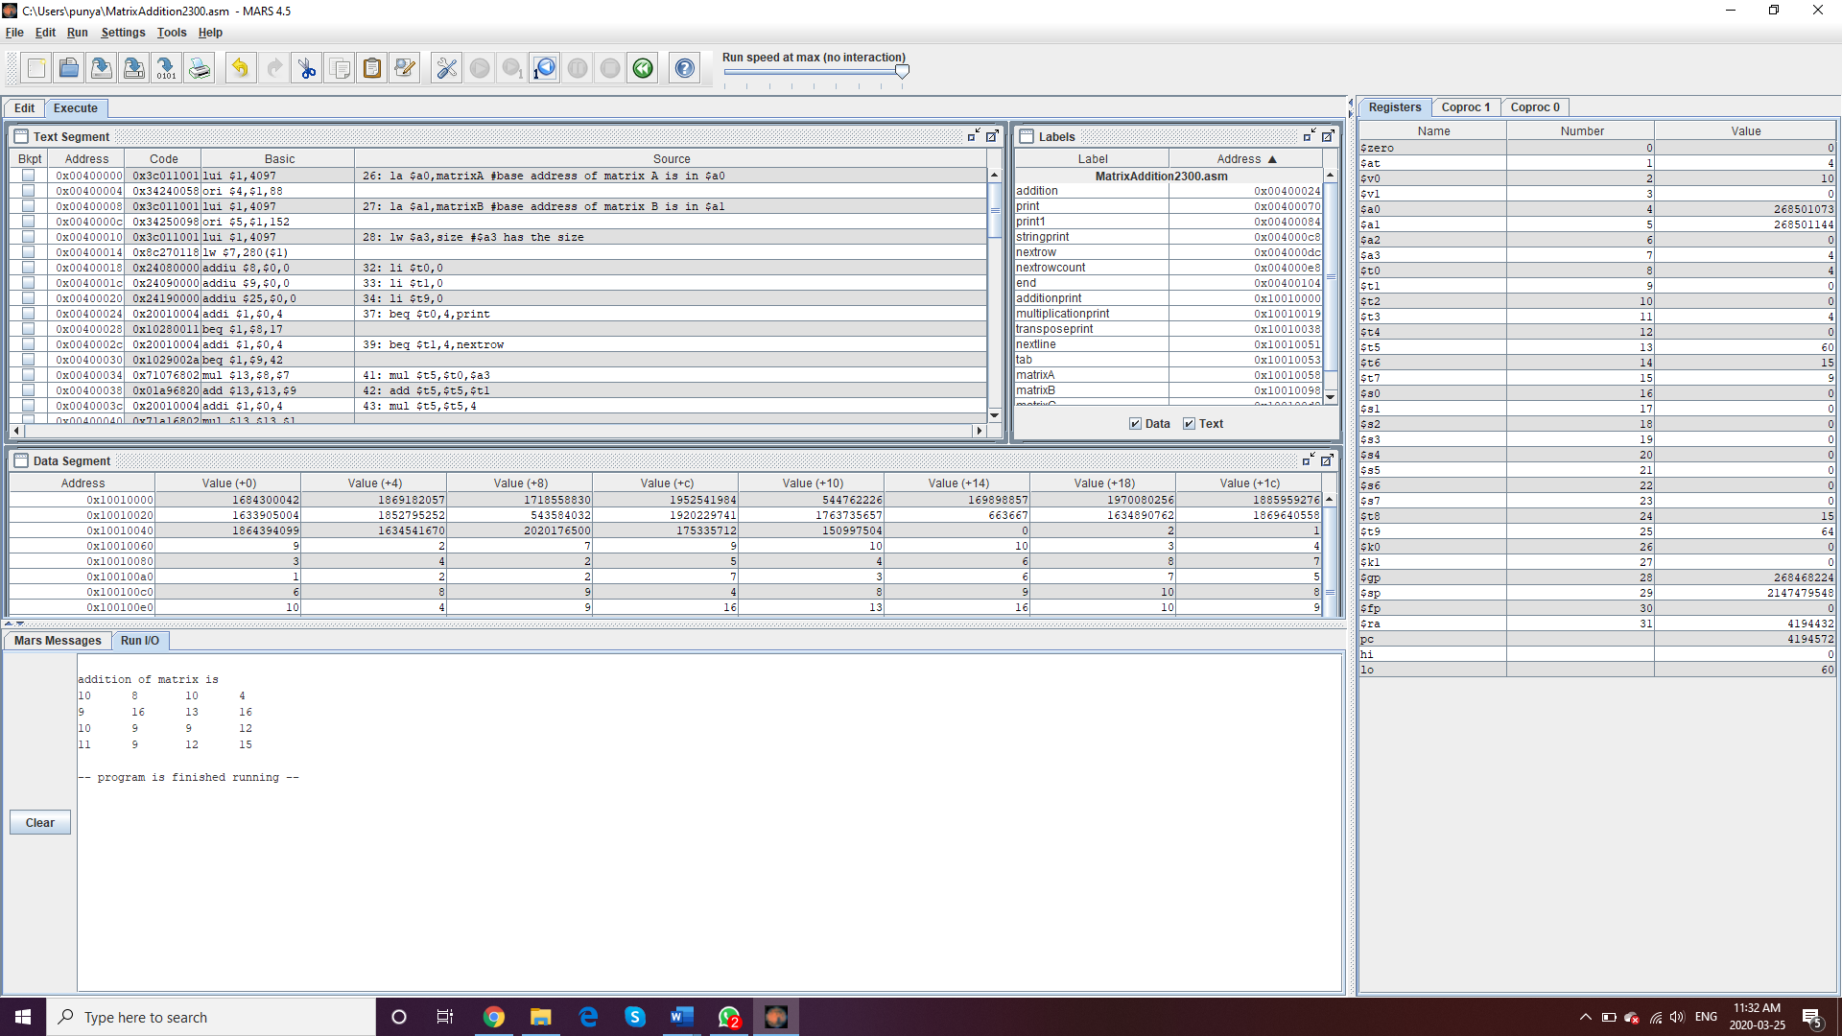

The multiplication of these two matrices are printed correctly: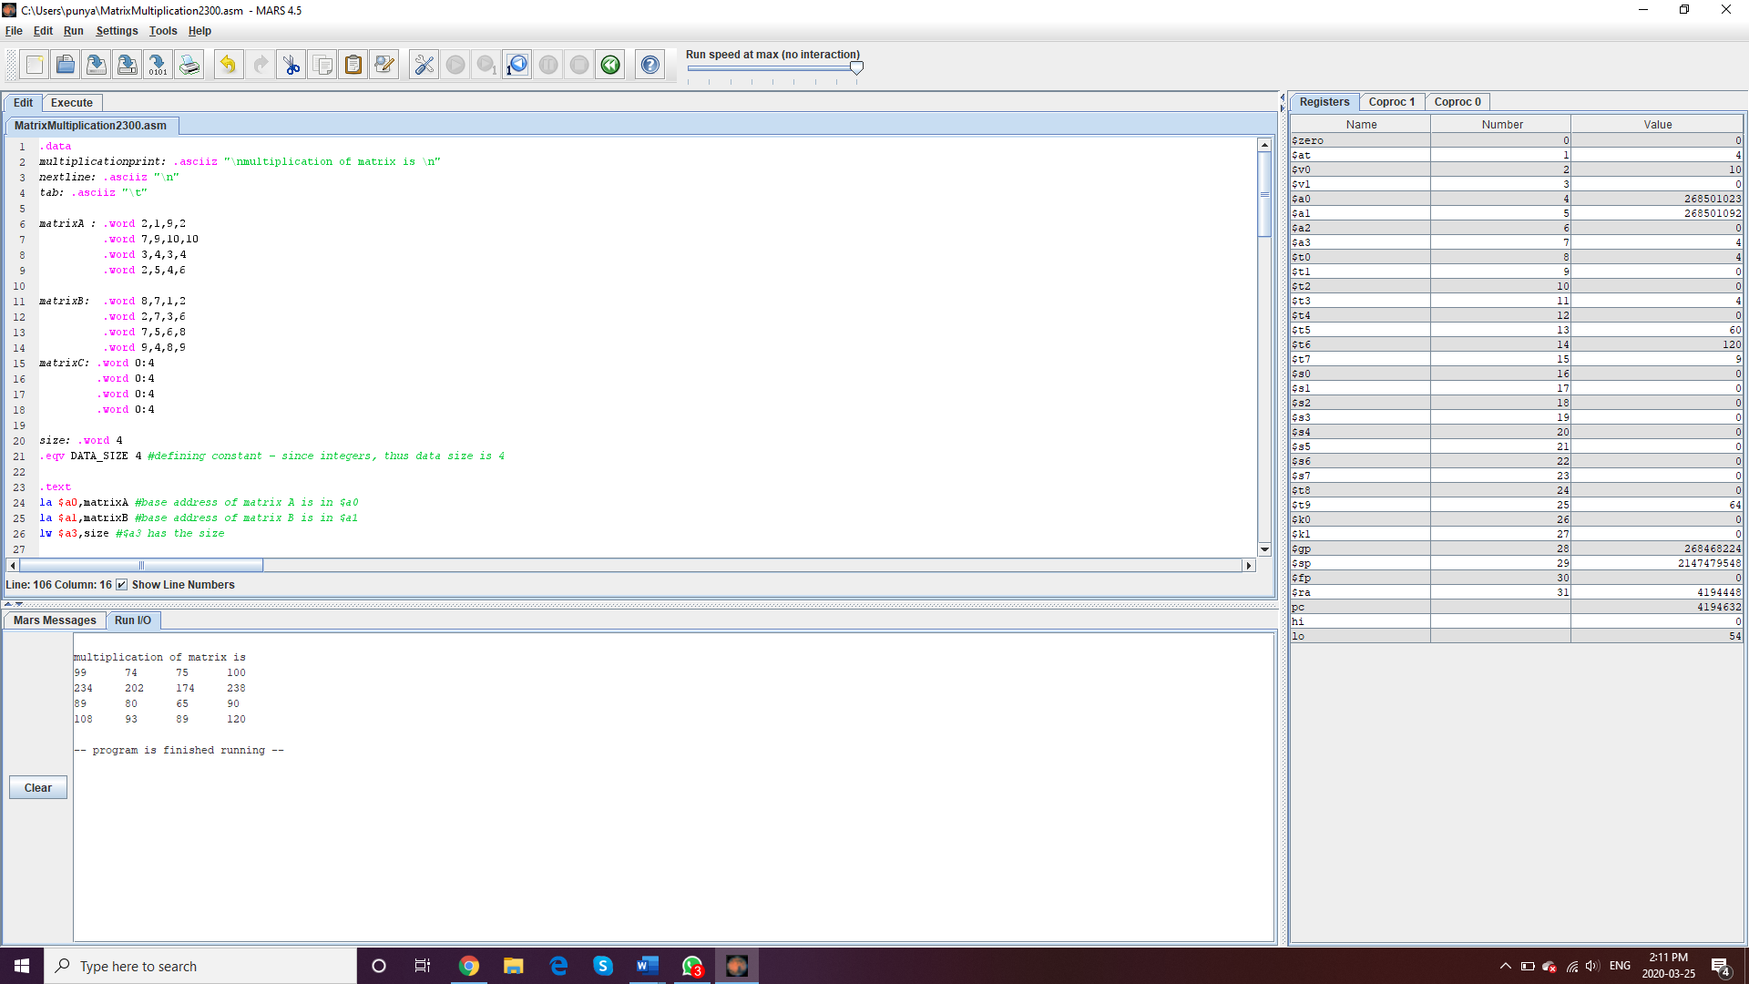

The transpose of the matrix A and B are printed correctly:

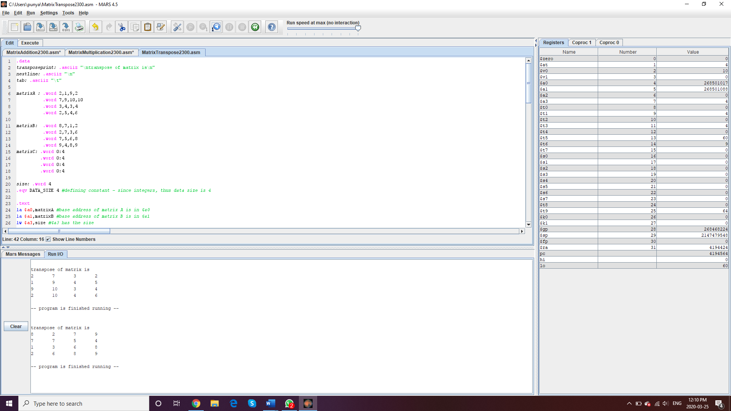

## Question 4: Floating point Programming (4 marks)

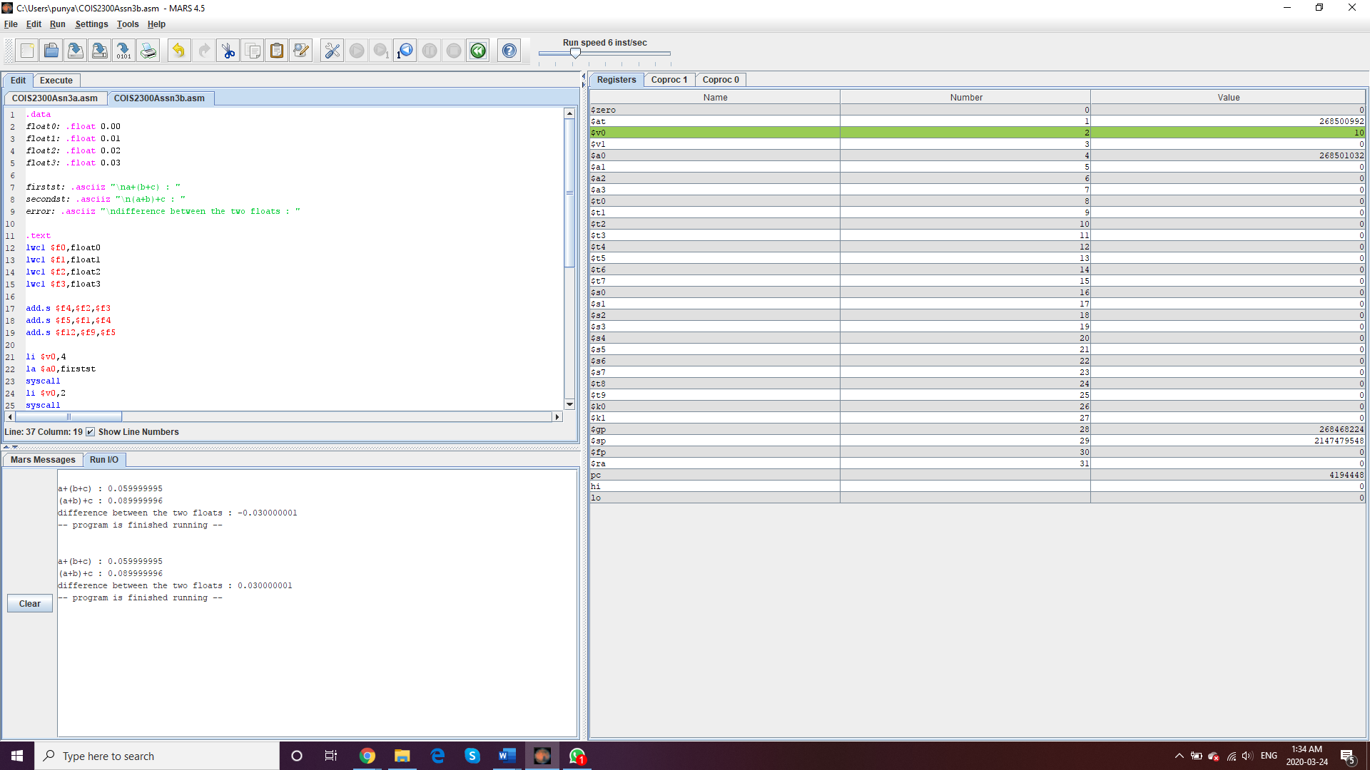

There are 3 floats 0.01, 0.02, 0.03

First Statement is a+(b+c) and then next statement is (a+b)+c and clearly as printed out, they are not equal and hence proved that for floating point values, associative property is not true.

Next statement shows the difference between the two floats, which is the ‘error’.